This time I did a front-end test.

The first thing I did was test the login page. Basic functions can be achieved, you can achieve the landing operation. At the same time, it has error correction function. If the input mailbox does not conform to the format, it will be reminded.

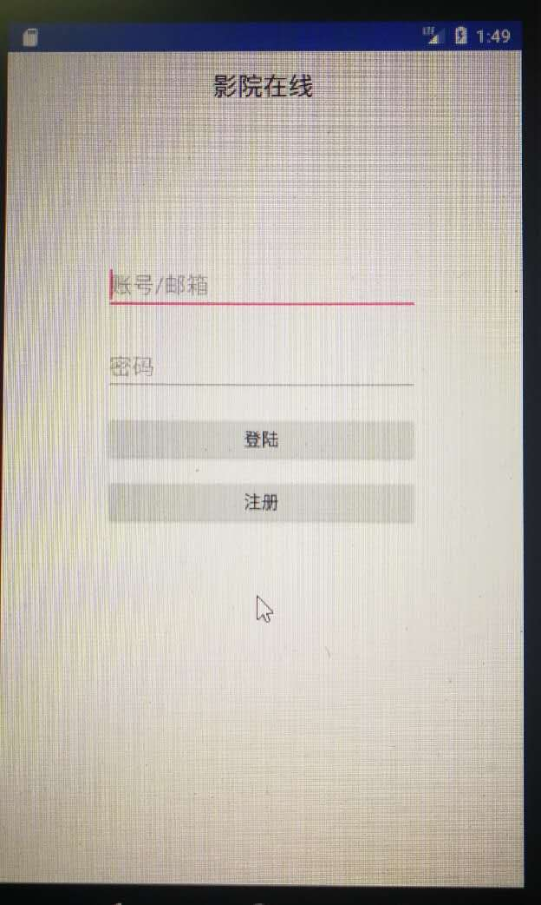

Enter the interface to see the film ranking, including the film rating and evaluation. The chart below shows the movie rankings.

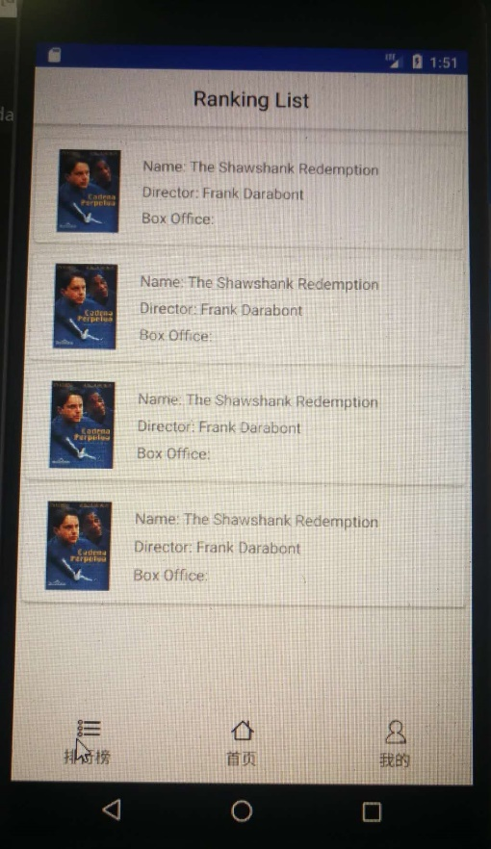

Enter my personal information interface, you can see their own orders and logout interface. Click on the order to see the movie tickets you bought.

